THE BRITISH FINN NATIONAL CHAMPIONSHIP 2021
Friday 9th to Sunday 11th July 2021
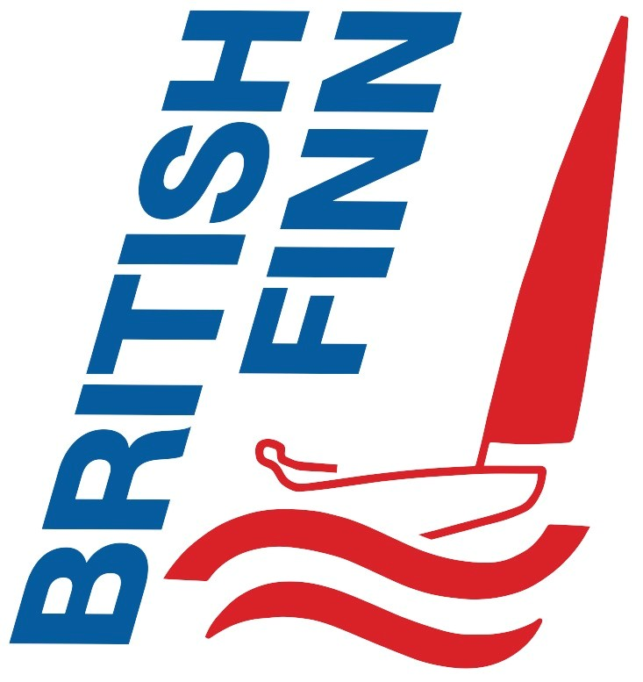
Royal Torbay Yacht Club
12 Beacon Terrace, Torquay, TQ1 2BH

Sail number ………………………Sailing Club……………………………

Helm (Given and Family name) ………………..…………………..….…

Please tick one of each row below
Standard Race Finn Classic with Carbon Classic Finn

U23 Open Master GM GGM Legend

Contact Details
Address | Postcode
Email
Emergency contact |  | Name

This declaration must be signed
I agree to be bound by the Racing Rules of Sailing and all other rules that govern this event. In particular, I have read the section of the Notice of Race covering the risk statement and agree to the statements contained in it.
The information you provide in this form will be used solely for dealing with you as a member of the BFA or by RTBYC. Both organisations have data protection policies. Your data will be stored and used in accordance with these policies. It will be destroyed when the event is completed, unless the law requires it to be further retained (e.g. for accounts). Please raise any queries concerning this policy with the Hon Sec of the BFA. The Policy details how personal data is processed to enable the BFA and The Club to perform its contracts with members concerning training etc. Data is retained for the legitimate interests of the BFA and RTBYC in operating a Finn sailing event.

The BFA or the Club may arrange for photographs or videos of racing and other activities, these may be published on the BFA or Club website or social media. If you consent to you/your child’s image being used by the Club in this way, then please tick here. □

Signed ………………………………….…………….Name ………………………………………Date of birth (if under 18)…………….…...

Entry Fee: £90.00 on or before 1st July 2021 or £110 thereafter .

Please enter by emailing this form to membershipsec@finnuk.org.uk

Parent or Guardian Declarations (Required if the helm is under 18)
Under Law, this helm is my dependent and I accept the safety section of the Notice of Race and agree to the statements contained within it. I confirm that my dependent is competent to take part and I am responsible for my dependent throughout the event. During the time my dependent is afloat I will be around RTBYC or I will inform the Race Officer in writing who is acting in loco parentis in my absence.

Signed …………………………… Name ………………………………..

Address ……………………………………………………………………………………………………………

