The British Finn Southern Championships

MENGEHAM RYTHE SAILING CLUB

Saturday May 18th –Sunday 19th 2019

Notice of Race

Organising Authority & Rules
  - The Organising Authority is MRSC (“the Club”) and this term includes its officers, the sailing committee, the race officers and assistants, the patrol boat crews and any other person involved in running the event.
1.2 The ‘rules’ as defined in The Racing Rules of Sailing (RRS), including Appendix P, shall apply.
2. Advertising
2.1. Boats may be required to display advertising chosen and supplied by the organizing authority and the
Class Association.

2. Conditions of Entry
  - Boats shall be insured for at least £3m against third party claims.
2.2 Competitors are required to agree to be bound by the ‘rules’ thereby accepting that they participate at their own risk (RRS 4). By entering and racing they agree to this condition, and specifically acknowledge that:
a) they are aware of the inherent element of risk involved in dinghy racing and of their responsibility for the exposure of themselves and the boat to such risk and for the safety of the same whilst afloat;
b) they are responsible for any injury, damage or loss caused by their actions or omissions, and have valid third-party liability insurance with minimum cover of £3m;
c) their boat is fit, and its crew competent, to sail in the conditions likely to be encountered;
d) the provision of a race management team and patrol boats does not relieve them of their responsibilities and patrol boat cover is limited to such assistance, particularly in extreme weather conditions, as can be practicably provided in the circumstances.
e) it is their responsibility to familiarise themselves with any risks specific to this event drawn to their attention in any rules and information produced for event and to attend any safety briefing.
2.3 Helms shall be members of their National Finn Class Association.
2.4 Boats shall carry the bow numbers allocated to them on entry affixed to either side of the hull forward of the mast.
2.5 Competitors are required to agree to grant the organising authority and any event sponsors the right in perpetuity to make, use and show (without attribution of competitor’s name) any photography, audio and video recordings, and other reproductions of them made at the Championship, without payment.

3. Entry Fee
3.1 £35.

4. Schedule

4.1 Registration at MRSC May 18th 08.00- 08.30, when this Notice of Race and the Sailing Instructions will be available.
  - There will be a briefing for competitors in the clubhouse at 08.30 May 18th.
  - Intended Race Times Warning Signal High Tide Height

Saturday Race 1 10.25 12.00 4.9m
Race 2 & 3 Following Race 1
Sunday Race 4 10.25 12.43 4.8m
Race 5 & 6 Following Race 4
4.4 The actual number of races on any day may be varied in the light of forecast weather conditions but no more than four races shall be sailed on any one day.
4.5 No race shall start later than 14.30 on Sunday.

5. Class flag
5.1 The class flag shall be the Class Insignia.

6. Courses and Race area
6.1 Courses will be triangular or windward/leeward, laid in Hayling Bay, usually Hayling Bay West, (unless weather conditions require them to be laid in Chichester Harbour, being signalled ashore by Code Flag H).
6.2 A chart of the racing areas is attached to the sailing instructions.

7. Safety [changing RRS 63.1]
7.1 Signing on/off: on entry each competitor will be given a numbered tally. This must be removed from the board situated in the club foyer, to signify that the competitor is going afloat, and returned to the board
within an hour of the last boat finishing the last race of the day. Failure to comply will incur a £5 fine to be donated to the RNLI, or, if not paid, disqualification without hearing not being discarded under 10.2.
7.2 Retirements: any competitor retiring from a race must notify the committee boat or a patrol boat as soon as possible, and once ashore must notify the onshore official that they have retired from the racing.
7.3 Competitors are advised in the interest of safety to leave West Pole Beacon to the north when sailing to or from the race area in Hayling Bay West.

- Time limits
There is no race time limit; races are intended to last for approximately 50 minutes. There may be an individual time limit within which boats after the first boat shall finish (see SI 7.1).

9. Shortening courses or Abandoning races [changing RRS 32]
9.1 Courses may be shortened, or races abandoned, at the discretion of the Race Officer.

10. Scoring
10.1 Two races shall constitute a championship series.
10.2 When 4 or more races are completed one race shall be discarded.

11. Communication with Competitors
11.1 Notices shall be posted on the official notice board in the clubhouse foyer.
11.2 Signals ashore shall be made from the Club flagstaff.
11.3 Changes to sailing instructions or this notice of race shall be posted at least two hours before the first race of the day, except that a change in race times shall be posted by 18.00hrs on the day before it applies.
11.4 Notice shall be posted each day of the time by which protests shall be lodged.
11.5 Notice of the time, parties and witnesses for a protest hearing shall be posted within 45 minutes of the protest time limit.

12. Exoneration Penalty
  - Where a boat could have taken a penalty under RRS 31.2 (touching a mark) or 44.1 (a possible breach of a rule of Part 2) but did not, an exoneration penalty of a 30% scoring penalty calculated under RRS 44.3(c) shall apply
12.1.1 if, after finishing and before a related protest hearing, she notifies the race committee that she accepts an exoneration penalty; or
12.1.2 if both parties to a valid protest agree that it be arbitrated by a member of the protest committee and, subject to the arbitrator deciding that the protest should be heard under RRS 63.1, that the decision be regarded for purposes of the RRS as that of the protest committee (amending RRS 63.1).

13. Outside Assistance (Changing RRS 41(a) & 63.1)
13.1 Assistance in getting back aboard the boat shall be added to the assistance permitted under RRS 41 (a).

14. Measurement
14.1. Each boat shall be able to produce a valid measurement certificate at the Championship.
14.2. A maximum of 2 masts and 2 sails shall be used during the Championship.

___________________________________________

Race Committee
Robert Macdonald (PRO), Graeme Macdonald, David Proctor.

Protest Committee
Chairman: Graeme Macdonald
___________________________________________

Social Events
Refreshments will be provided after racing each day.

Camping
Facilities for camping and motor homes are available free of charge at the Club subject to booking in advance through sailingsec@mengeham.org.uk.

Accommodation
For local accommodation google hayling-accommodation.co.uk

Mengeham Rythe Sailing Club
The GAC Pindar British Finn Championships Sailing Instructions

1. Rules
1.1 The ‘rules’ as defined in the Racing Rules of Sailing (RRS), including Appendix P, shall apply.
  - Provisions as to Class flag, Safety, Scoring system, Time Limit, Communication with competitors and Exoneration Penalty shall be as in the Notice of Race.

2. Schedule of races
  - The time of the Warning signal for the first race each day shall be:
Saturday 10.25; Sunday 10.25.

2.2 A postponement signal shall precede the start sequence for subsequent races each day by at least four minutes.

3. Courses
  - Courses as in 3.3 shall be displayed for each class on a board showing a letter A, B, or C, and the compass bearing from the start to mark 1.

3.2 A change before the start in a course already displayed shall be signalled by hoisting Code Flags L over C until the warning signal.

3.3 Course A: Start - W- Wa - Gate - W - Wa - Gate - Finish
Course B: Start - W- Wa - Gate - W - G - Gate - Finish
Course C: Start - W- Wa - Gate - W - G - Gate - W - Wa - Gate - Finish
Course A (Windward/Leeward) |  | Courses B & C (Triangular)
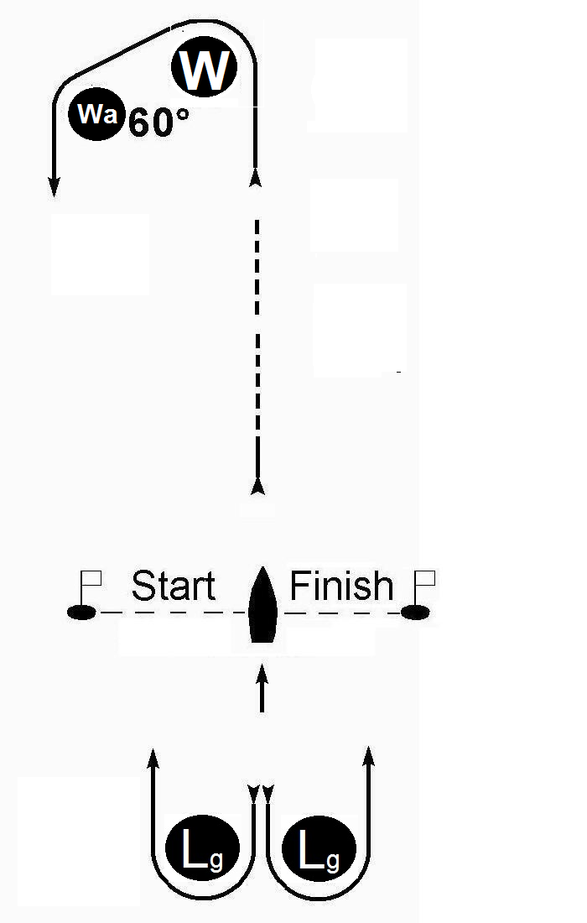 | WIND | 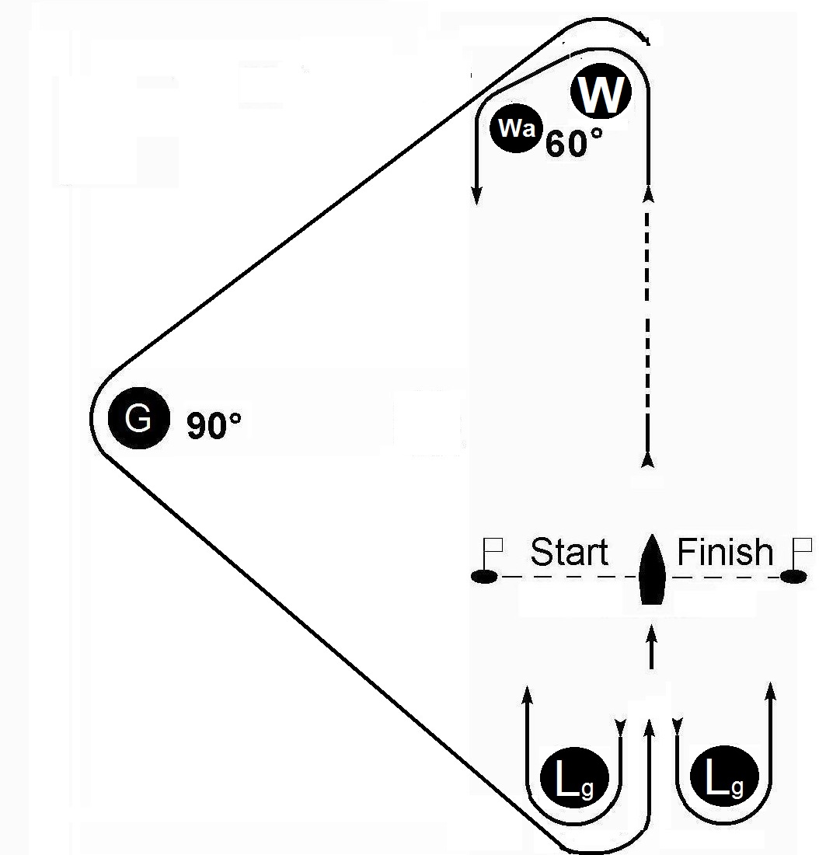
(For the purpose of the diagram marks are to Port – see 3.4; angles are indicative only.)
“Gate” requires boats to pass between the two marks Lg, and in courses B & C, when the previous mark is G, to pass through the gate in the direction of the finish line.

  - Marks shall be left to Port when a rectangular red flag, and to Starboard when a triangular green flag, is flown, except that for Gate marks Lg shall be left so as to pass through the gate.
3.5 Subject to 5.1, marks W and Lg shall be large dumpy orange marks marked “Jobsite”, Wa shall be a small dumpy orange mark, and mark G shall be a large dumpy blue mark

4. Starting and Finishing
4.1 The starting and finishing lines shall both be in the same vicinity, and each shall be between the mast of the committee boat flying an orange flag and
for starting, a dan buoy flying an ORANGE flag;
for finishing, a dan buoy flying a BLUE flag.

5 Change of course after the start (adding to RRS 33)
5.1 A new mark 1 of courses A-C shall be black and a subsequent changed mark 1 shall revert to orange; other marks shall remain as in 3.5.
5.2 In the event of a missing gate mark(s) the gate shall be replaced, without signal, by a single mark or a boat flying Flag M to be rounded in the direction signalled under 3.4.
5.3 In courses B and C mark G may be removed, being signalled by a boat at Mark 1 displaying Code flag C above a flag lettered A (together with any other change of course signal).

6. Shortened course (changing RRS 32)
6.1 Boats shall round the mark, or sail through the gate, where the course is shortened and sail directly to the finishing line, except
6.1.1 when a blue flag is flown below Code Flag S boats shall finish at the mark in accordance with RRS 32.2.

7 Individual time limits (changing RRS 35 and A4)
7.1 The Race Officer may apply a time limit to boats finishing more than 15 minutes after the first boat: if applied such shall score points for the positions after the last boat to finish according to their relative positions prior to the expiry of the limit at a mark, or marks, determined by the Race Committee. Expiry of the limit shall be when signalled by code flag N over a blue flag with three sound signals.

8 Protest Time Limit
8.1 Protests shall be lodged within 90 minutes of the finish of the last boat in the final race of the day.
___________________________________________________

The chart and tidal information does not form part of the Sailing Instructions
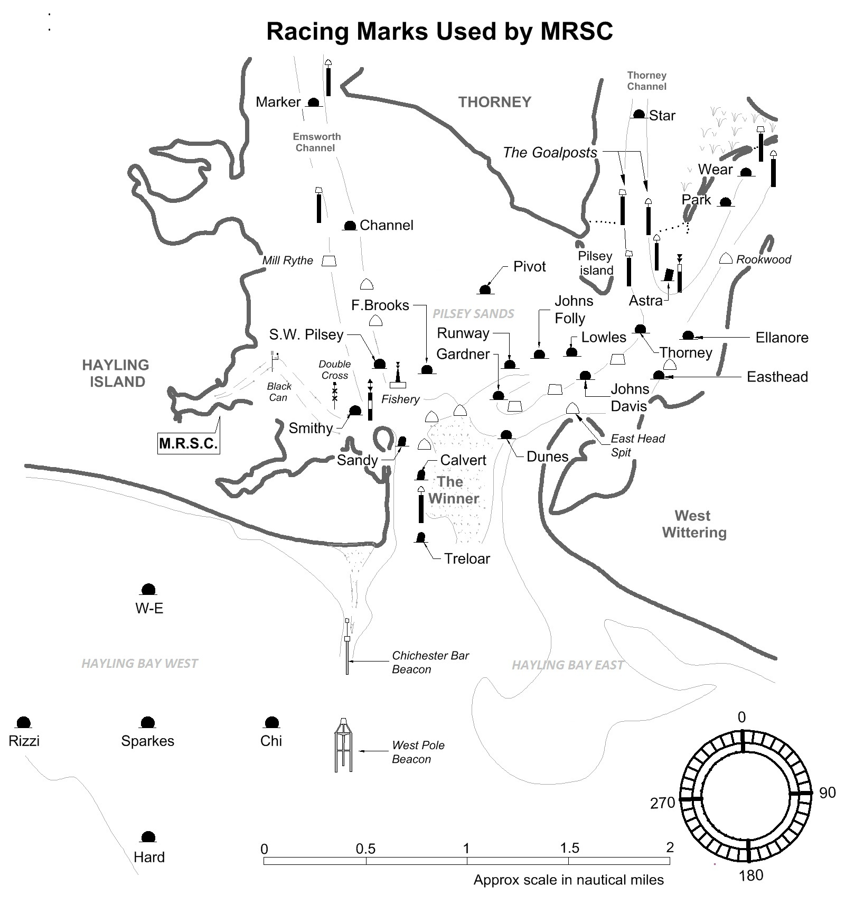

Approximate direction & rate of tidal stream at 50° 45.3’ N, 0° 59.6’ W
270° & 2 miles from West Pole Beacon
 | Hours before H W |  |  |  |  |  | HW | Hours after H W
Hours | 6 | 5 | 4 | 3 | 2 | 1 |  | 1 | 2 | 3 | 4 | 5 | 6
Direction | 72 | 82 | 73 | 38 | 320 | 301 | 279 | 259 | 230 | 152 | 128 | 118 | 75
Rate (knots)
Spring | 0.5 | 0.7 | 0.6 | 0.3 | 0.4 | 0.7 | 0.9 | 0.9 | 0.5 | 0.6 | 0.6 | 0.3 | 0.4
Neaps | 0.3 | 0.4 | 0.3 | 0.2 | 0.2 | 0.4 | 0.5 | 0.4 | 0.3 | 0.3 | 0.3 | 0.1 | 0.2

TIDES
DATE | HIGH WATER
 | TIME | HEIGHT
Sat May 18th | 12.00 | 4.9m
Sun May 19th | 12.43 | 4.8m

