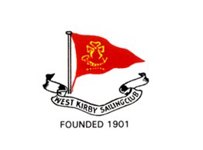
West Kirby Sailing Club

West Kirby Sailing Club, situated on the Wirral peninsula, is the largest sailing club in the North West of England.
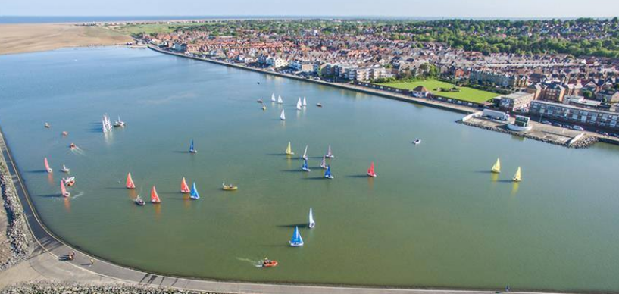
The club offers a unique opportunity to combine tidal and lake racing. The sailing club has run numerous championships in the past, from the World Team Racing Championship involving 32 teams sailing in Fireflies, to Finn nationals, Firefly nationals, GP 14 Masters, Albacores and Finn Nothern Championships etc… The club recently ran the North West Junior Travellers Trophy, providing both tidal and lake racing to around 75 participants.
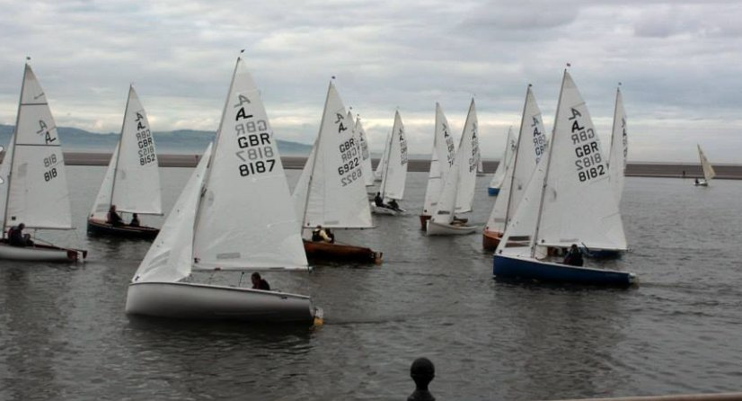
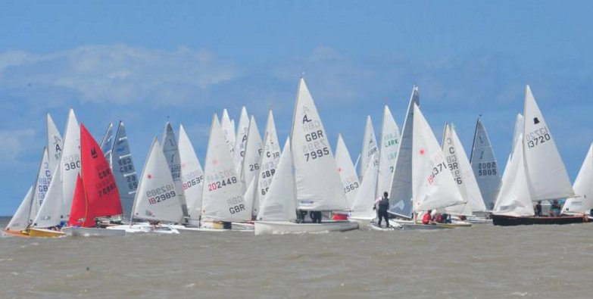

Club facilities:
The club is fully equipped with changing rooms, showers… It is fully licenced and offers food from the galley operated by its members.

Accomodations:
There are numerous reasonably priced hotels and B&B within 2 miles from the sailing club. Alternatively, visiting competitors may be able, by prior arrangements, to stay with club members. Campervans may be parked on South Parade, which runs alongside the lake, and within the club grounds. Trailers can be parked in the club grounds or on the lake apron.

How to get there:
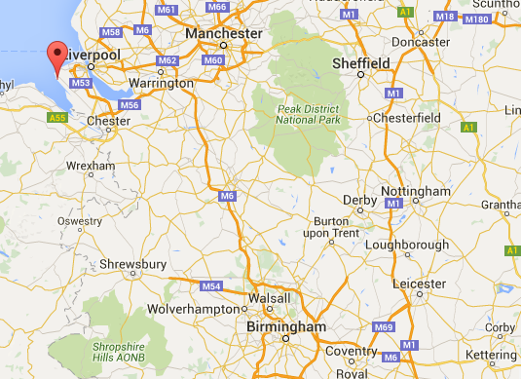
West Kirby Sailing Club, Sandy Lane, West Kirby, Wirral, CH48 3HZ. 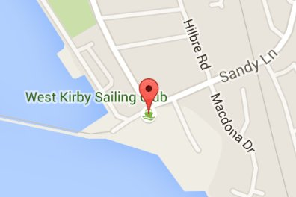

Contacts:
West Kirby Sailing Club: 0151 625 5579 – Office@wksc.org.uk
Jean-Louis Simons: 07787516163 – jeanlouis.simons@btinternet.com

